MEDICAL ETHICS - THE THREE PILLARS
Hippocrates oath and 3 principles ethic: Autonomy, Beneficence, Justice. End-of-life care, triage as an ethical question

- WHAT’S SPECIAL ABOUT MEDICINE?
Throughout almost all recorded history and in virtually every part of the world, being a physician has meant something special. People come to physicians for help with their most pressing needs– relief from pain and suffering and restoration of health and wellbeing. They allow physicians to see, touch and manipulate every part of their bodies, even the most intimate. They do this because they trust their physicians to act in their best interests. Moreover, physicians frequently must deal with medical problems resulting from violations of human rights, such as forced migration, terrorism at assaults and torture. And they are greatly affected by the debate over whether healthcare is a human right, since the answer to this question in any country largely determines who has access to medical care. There is a high level of social interaction between medicine and patients and society needs. That´s the reason why medical ethics is also closely related to law.
- MEDICINE AS ARTS
Medicine is both science and arts.
Science deals with what can be observed and measured, and a competent physician recognizes the signs of illness and disease and knows how to restore good health. But scientific medicine has its limits, particularly regarding human individuality, culture, religion, freedom, rights and responsibilities.
The art of medicine involves the application of medical science and technology to individual patients, families and communities, no two of which are identical. We know that a major part of the differences among individuals, families and communities is non-physiological, and it is in dealing with these differences that the arts, humanities, culture and social sciences, along with ethics, play a major role.
Ethics has been an integral part of medicine at least since the time of Hippocrates, the fifth century B.C.E. (before the Christian era). Hippokrates was a Greek physician who is regarded as a founder of medical ethics. From Hippocrates came the concept of medicine as a profession, in which physicians do publicly promise that they will place the interests of their patients above their own interests.
In recent times medical ethics has been greatly influenced by developments in human rights.
In a pluralistic and multicultural world, with many different moral traditions, the major international human rights agreements can provide a fundament for medical ethics that is acceptable across national and cultural borders.
- WHO DECIDES WHAT IS ETHICAL?
Ethics is pluralistic. So, we as academics search for a common denominator which serves to our work. Individuals disagree among themselves about what is right and what is wrong, and even when they agree, it can be for different reasons. In some societies, this disagreement is regarded as normal and there is a great deal of freedom to act however one wants, if it does not violate the rights of others. In more traditional societies, however, there is greater agreement on ethics and greater social pressure, sometimes backed by laws, to act in certain ways rather than others. In such societies culture and religion often play a dominant role in determining ethical behavior.
The answer to the question, “who decides what is ethical for people in general?” therefore varies from one society to another and even within the same society.
    - In liberal societies, individuals have a great deal of freedom to decide for themselves what is ethical, although they will likely be influenced by their families, friends, religion, the media and other external sources.
    - In more traditional societies, family and clan elders, religious authorities and political leaders usually have a greater role than individuals in determining what is ethical.
    - Despite these differences, it seems that most human beings can agree on some fundamental ethical principles, namely, the basic human rights proclaimed in the United Nations Universal Declaration of Human Rights and other widely accepted and officially endorsed documents.
    - The human rights that are especially important for medical ethics include the rights to
      - life
      - freedom from discrimination, torture and cruel, inhuman or degrading treatment
      - freedom of opinion and expression
      - equal access to public services in one’s country
      - medical care
For physicians, the question, “who decides what is ethical?” has until recently had a somewhat different answer than for people in general. Over the centuries the medical profession has developed its own standards of behavior for its members, which are expressed in codes of ethics and related public documents.
First penned around 400BC, the Hippocratic Oath sounds a bit old-fashioned today:
    - I swear by Apollo the physician, and Aesculapius, and Health, and All-heal, and all the gods and goddesses, that, according to my ability and judgment, I will keep this Oath and this stipulation—to reckon him who taught me this Art equally dear to me as my parents, to share my substance with him, and relieve his necessities if required; to look upon his offspring in the same footing as my own brothers, and to teach them this Art, if they shall wish to learn it, without fee or stipulation; and that by precept, lecture, and every other mode of instruction, I will impart a knowledge of the Art to my own sons, and those of my teachers, and to disciples bound by a stipulation and oath according to the law of medicine, but to none others. I will follow that system of regimen which, according to my ability and judgment, I consider for the benefit of my patients and abstain from whatever is deleterious and mischievous. I will give no deadly medicine to any one if asked, nor suggest any such counsel; and in like manner I will not give to a woman a pessary to produce abortion. With purity and with holiness I will pass my life and practice my Art. I will not cut persons laboring under the stone but will leave this to be done by men who are practitioners of this work. Into whatever houses I enter, I will go into them for the benefit of the sick and will abstain from every voluntary act of mischief and corruption; and, further from the seduction of females or males, of freemen and slaves. Whatever, in connection with my professional practice or not, in connection with it, I see or hear, in the life of men, which ought not to be spoken of abroad, I will not divulge, as reckoning that all such should be kept secret. While I continue to keep this Oath unviolated, may it be granted to me to enjoy life and the practice of the art, respected by all men, in all times! But should I trespass and violate this Oath, may the reverse be my lot!
    - Short: I swear by Apollo the physician, and Aesculapius, and Health, and All-heal, and all the gods and goddesses, that, according to my ability and judgment, I will keep this Oath …I will give no deadly medicine to any one if asked, nor suggest any such counsel; and I will not give to a woman a pessary to produce abortion...!
At the global level, the World Medical Association (WMA) has set forth a broad range of ethical statements that specify the behavior required of physicians no matter where they live and practice. In many, if not most, countries medical associations have been responsible for developing and enforcing the applicable ethical standards. Depending on the country’s approach to medical law, these standards may have legal status.
    - The Declaration of Geneva (2017), as published by the World Medical Association^{[6]}:
AS A MEMBER OF THE MEDICAL PROFESSION:
      - I SOLEMNLY PLEDGE to dedicate my life to the service of humanity;
      - THE HEALTH AND WELL-BEING OF MY PATIENT will be my first consideration;
      - I WILL RESPECT the autonomy and dignity of my patient;
      - I WILL MAINTAIN the utmost respect for human life;
      - I WILL NOT PERMIT considerations of age, disease or disability, creed, ethnic origin, gender, nationality, political affiliation, race, sexual orientation, social standing or any other factor to intervene between my duty and my patient.
      - I WILL RESPECT the secrets that are confided in me, even after the patient has died.
      - I WILL PRACTICE my profession with conscience and dignity and in accordance with good medical practice.
      - I WILL FOSTER the honor and noble traditions of the medical profession.
      - I WILL GIVE to my teachers, colleagues, and students the respect and gratitude that is their due.
      - I WILL SHARE my medical knowledge for the benefit of the patient and the advancement of healthcare.
      - I WILL ATTEND TO my own health, well-being, and abilities to provide care of the highest standard.
      - I WILL NOT USE my medical knowledge to violate human rights and civil liberties, even under threat.
      - I MAKE THESE PROMISES solemnly, freely and upon my honor.

The ethical directives of medical associations are general in nature; they cannot deal with every situation that physicians might face in their medical practice. In most situations, physicians must decide for themselves what is the right way to act, but in making decisions, it is helpful to know what other physicians would do in similar situations. So, communication among the medical professionals is essential.
- WHAT MEDICAL ETHICS IS ABOUT
Medical practice is frequently an ethical and legal minefield.
So, what helps us manage these dilemmas in an effective way?
Medical ethics are the basis of what will guide your decision making as a doctor or a nurse, so you need to have a good idea of them and be able to show that you have the capability to make such decisions in the future.
Medical Ethics explores the unique interplay between
    - Justice
    - patient autonomy
    - law

To put it simply, ethics drive our behavior, not the law. So, the law largely reflects ethics.
A way of mutual understanding of this unique interplay reflects the essential three principles of ethics.

- THE 3 PILLARS OF MEDICAL ETHICS
The ethical principles that form the foundation of decision-making in medicine are referred to as the ‘Three Pillars of Medical Ethics’.‍
- Autonomy (Respect)
- Beneficence (non-maleficence)
- Justice‍
These principles are considered universal, transcending geographic, cultural, economic, legal, and political boundaries.
  - Autonomy‍‍
This is the most important pillar of medical ethics. It gives patients who are competent enough the right to make decisions about their own healthcare. Essentially, it means that the patient has a say and oversees its own care.‍ A central idea of Autonomy is the Respect for Persons (and Community).
- Capacity to decide, make choices
- The dignity of people and the individual
- Respect for the community and local culture
An example of autonomy: If a doctor needs to take a patient’s bloods, then the consent of the patient is important. The patient has the right to refuse the blood test.‍
Note: in the scenario we are assuming that the patient has the capacity to consent.‍
  - Beneficence‍ (Non-maleficence‍‍)
This principle means that medical practitioners will always act for the benefit of their patients. It refers to
- Physical, mental, and social well-being
- Risks reduced to a minimum (non-maleficence)
An example of beneficence: If a patient requests antibiotics but the doctor knows of a better alternative treatment, then the doctor will use their expertise to give the patient the treatment that is best for them.‍
  - Justice‍
This considers whether an action is ethical, compatible with the law, respects the patient’s rights, and is fair and balanced.‍‍ It refers to
- Distribution of risk and benefit
- Special protection for vulnerable groups
An example of justice: Fair distribution of resources in a hospital. ‍‍It is also worth considering different ethical theories. ‍
A special case of justice: A special group to which we must be vigilant are the most Vulnerable in our societies:
- Pregnant women, children, prisoners
- Mentally ill
- Those with limited education
- The poor
- Those with difficult access to health services
- TRIAGE – A SPECIAL PROBLEM ABOUT LIFE DECISIONS
Emergency Triage systems facilitate the categorization of emergency patients according to their disease severity and determine both treatment priority and treatment location. The Emergency Severity Index (ESI, USA) first excludes life-threatening and severe disease before stratification according to estimated resource utilization. The goal of all triage systems is to reduce the in-hospital mortality and to minimize time to treatment, length of stay, and resource utilization. ESI was developed by the two US-American physicians Richard Wuerz and David Eitel. They created in 1998 a triage instrument to facilitate prioritization of patients based on urgency of treatment and conditions. The First principal triage question was “Who should be seen first?”. Wuerz and Eitel soon realized there are often multiple patients of the same urgency. So, they changed their principal triage question to “How long can each patient safely wait?”
So now let´s have a look at the main guidelines of this ESI-system:
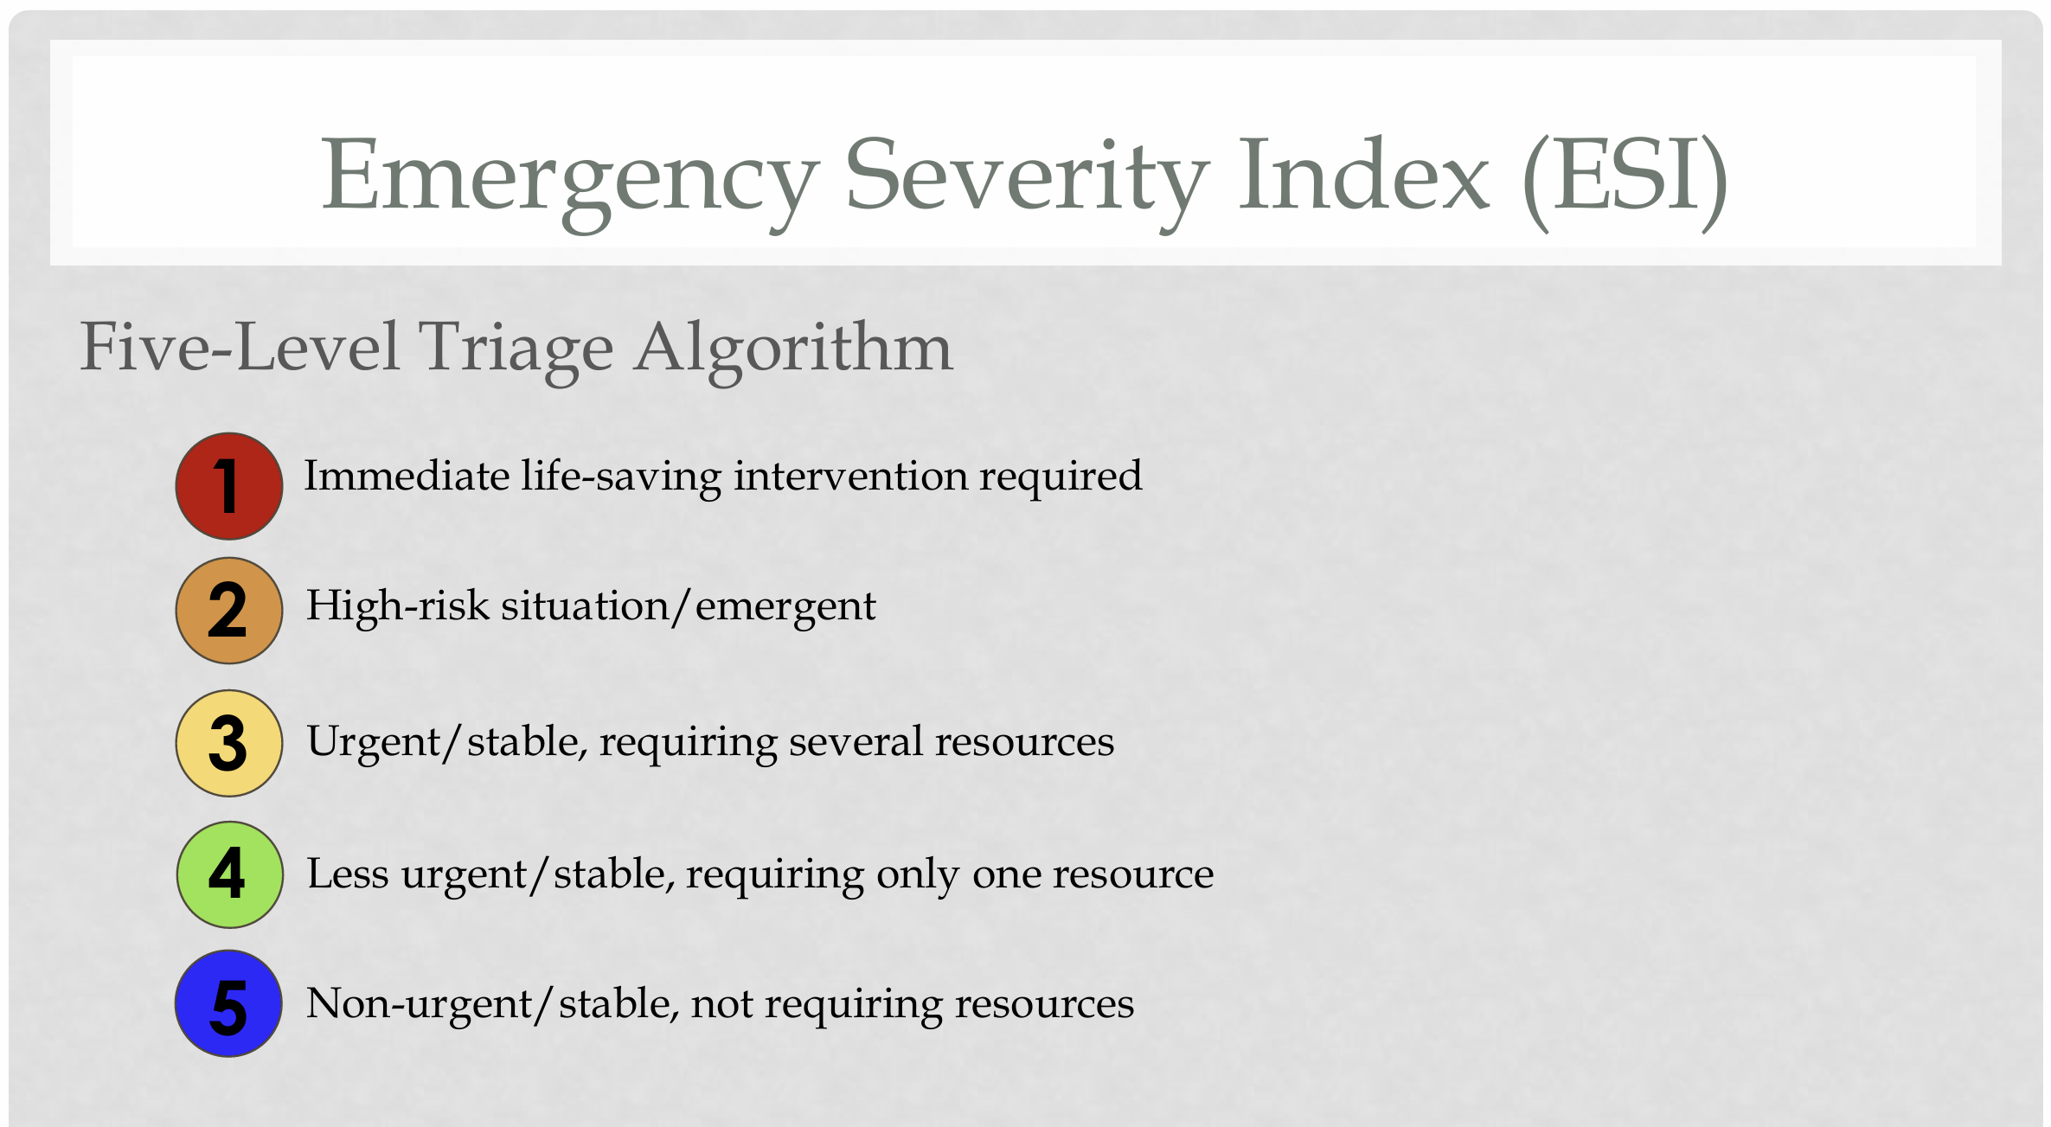
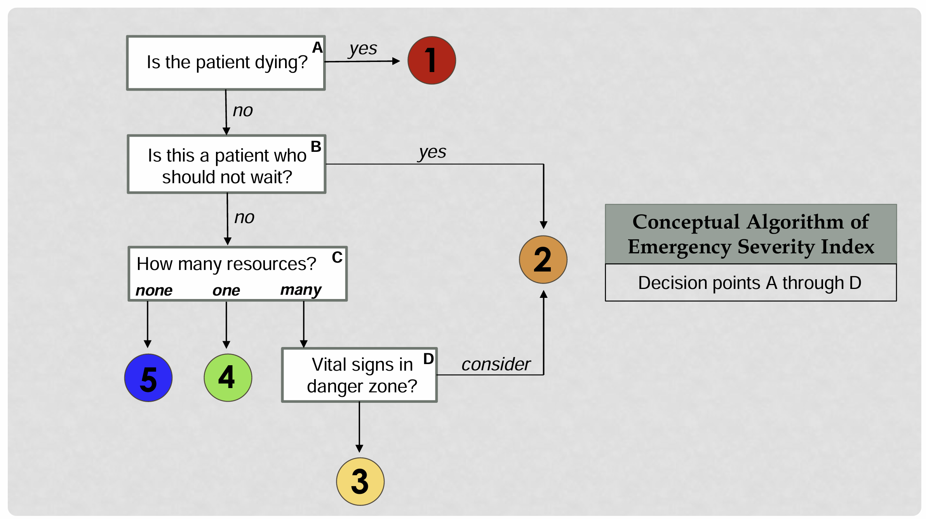 graphics cf.
To get deeper into this you should remember what we have spoken about some minutes before: communication among the medical professionals is essential. To read, discuss and proof in practice these rules of triage is a lifelong process of communication and learning. Never stop asking your medical staff about what they are doing. Learning in practice is the best way to improve theoretical knowledge. The main medical ethical advantages are to be curious, to learn, discuss and proof in practice. It´s the general system of ethical decisions, the 3-step method:
- SEE: What is the fact situation? Who is affected? Different interest groups may have different opinions on how a problem should be solved
- JUDGE: Ethical reflection: What ethical principles, norms and values play a role? Give good reasons
- ACTION: Formulate an opinion and act!

SUMMARY: In practice, you need to develop ethical procedures that lead from ethical principles to local guidelines. Therefore, the following is required:
- Knowledge of the local culture and resources available
- Community participation
I recommend three publications about the ESI-triage system and Ethics Training: - ESI Implementation Handbook by the U.S. Agency for Healthcare Research and Quality, - ESI HANDBOOK by the U.S. Emergency Nurses Association and – H. Stettler, The Emergency Severity Index (ESI) Triage Algorithm

All can be downloaded for free from my homepage elmarkuhn.com

Cf. World Medical Association Medical Ethics, Manual 2015^{3rd}, 11
World Medical Association Policy Handbook(http://www.wma.net/en/30publications/10policies/) – contains the full text of all WMA policies (in English, French and Spanish)World Medical Association Ethics Resources(http://www.wma.net/en/20activities/10ethics/index.html)
ESI Handbook download: https://californiaena.org/wp-content/uploads/2023/05/ESI-Handbook-5th-Edition-3-2023.pdf
Cf. Weyrich, P., Christ, M., Celebi, N. et al. Triagesysteme in der Notaufnahme. Med Klin Intensivmed Notfmed 107, 67–79 (2012). https://doi.org/10.1007/s00063-011-0075-9
Graphics by H. Stettler, Erlanger East Hospital Chattanooga, Tennessee, The Emergency Severity Index (ESI) Triage Algorithm, published at Texas Tech University Health Sciences Center (http://ttuhsc.edu/), Nursing 314121
Cf. R.Rivera, D.Borasky, Research Ethics Training Curriculum^{2nd}, Family Health International, USA 2009

