**1.3 Cultural Diversity in ethics**

Interreligious social ethics provides an appropriate framework for discussions in a pluralistic society. Starting with a reflection on practical issues of social life, it turns to positions of other religions, from where results a new perspective on one’s own position. Interreligious social ethics practices a method of “careful comparison” to prevent an inadequate appropriation of other religions. It provides an alternative to neutralizing theological argument in public debates.

1. **SOCIAL ETHICS AS A LINK BETWEEN CULTURES**

The basic thesis is, that **social ethics** is a key not only for Christian theology, but also for Islamic theology and for interreligious dialogue.

The reality of Islam AND Christianity and some animistic religions in Nigeria require a new kind of ethics.   
My approach gives an indication of what such a movement of thought might look like:

* It starts with concrete questions of social practice
* then turns to positions of the other religion
* before a new view of our own emerges.

This diversity of perspectives does not have to lead to a consensus, rather, different religious social ethics can stand side by side in a plurality.

Hans Joas makes it clear that the value dialog is not about consensus, but about plausibility and "a dynamic mutual modification and stimulation for the renewal of one's own tradition ".[1]

Joas speaks of a process of human sacralization. In other words, a sanctification of the human being. Our ability to **freely decide for good or evil**, our ability to **think beyond death** and our ability to believe **distinguish us from the animals**. This ability to decide freely gives us a share in God's complete freedom of choice. It is our human characteristic of **dignity and holiness**.

The ability to use this freedom for evil also gives rise to the task of forming a conscience, as Thomas Aquinas already called for.

For the **believer, man is a creature of God**, endowed with freedom and dignity. For the **non-believer**, however, this is at least true: Man is capable of both good and evil decisions. Therefore, every human being has a **high level of responsibility and dignity**.

**Ethics** formulates these decisions and justifies them. **Theological ethics**, or as we call it here: **Religious** **morality**, shows us the way in the prophetic scriptures of our faith. However, we are always caught between society and the individual.

Let's look at the answers of the religions:

1. **ISLAM**

The word **INDIVIDUAL** is of Latin origin and means "indivisible unit". As such, there is no exact equivalent in Arabic. There, the individual is called "*fard*" or "*sˇah*", i.e. person, or *mukallaf*, the **legal entity**.[2]

In Islamic intellectual history, the concept of individualism has never been dealt ethically. The Qur'an states: *"Among you there shall be a community that invites to good, enjoins right and restrains from evil.[3]* And according to the tradition in the Book of Bukhari, the Islamic prophet Muhammad said: *"The most useful person is the one who is useful to other people."[4]* And basically, this is the summarized description of a righteous (*sālih*) and perfect (*kāmil*) Muslim: A faithful Muslim should thus be useful to the community

* **help** those who are working on something
* **be sensitive** and think of his fellow human beings
* speak to them in a **good tone**
* **reconcile** those who are at odds with each other
* **advise for good** and advise against evil
* listen to those who are troubled and **try to help**
* urge **patience**
* **be useful** to people in both material and spiritual ways
* **be merciful** to people Muslims should thus be useful to the community.[5]

Eastern culture, both in its Confucian and Islamic variants, has established the principle of **'community'** at the expense of the "**individual**". In this view, the independence of the individual has no value apart from being part of the community.[6]

In an Islamic society, the relationship between the individual and the community is fundamentally seen from the **perspective of the community**. Just as the rights and duties of the individual only unfold within the community, the individual only receives his or her identity from the community based on belonging to it.

*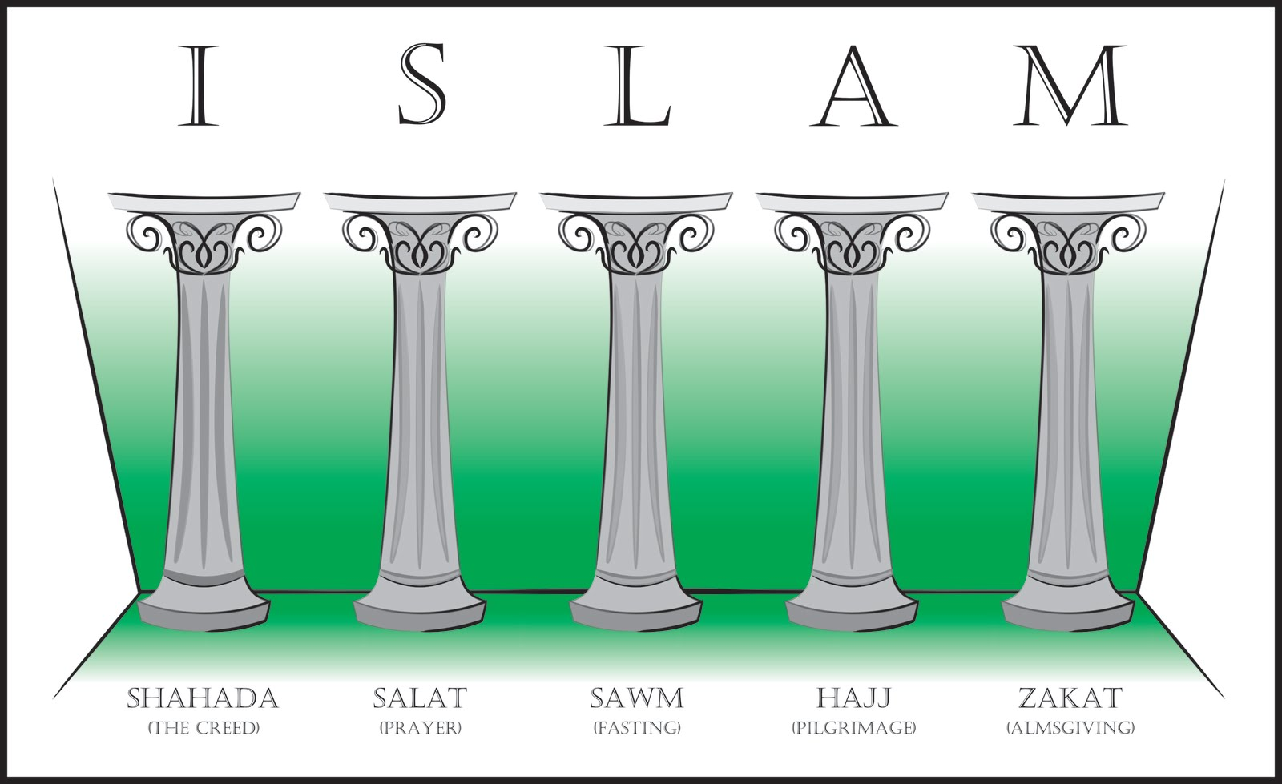 ©wikicommons*

The **five pillars of Islam** clearly show this primacy of the community. If we take a closer look at these duties, we immediately realize that they are **communal acts**.

These are the pillars of CREED (the only pillar that can be prayed alone), PRAYER (with an Iman and together), FASTING in the month of Ramadan (breaking the fast together), PILGRIMAGE to Mecca (being united in the community), and ALMSGIVING (turning to others).

1. **Judaism / Christianity**

The main part of the Jewish confession is the *Sh'ma Yisrael*: *״Hear, Israel, Yahweh is our God, Yahweh is one. And you shall love Yahweh your God with all your heart, with all your soul and with all your strength" (Deut 6:4-5)*. The commandment to love God can only be fulfilled by the individual, as it appeals to the heart as the willing and understanding center of the person.[7]

The individuality of the individual has developed in a dynamic process in modern Europe. However, this individuality is always also a mandate to protect the community. This reference to the power of the individual, also in relation to God, can already be found in the Old Testament:

In the story of Abraham's conversation with Yahweh before the destruction of Sodom: “*And Abraham came and said, 'Will you indeed destroy the righteous together with the wicked? And again Abraham said, "My Lord will not be angry if I only speak out once more. Perhaps there will only be ten there. And again the Lord said, "I will not destroy them for the sake of ten.” (Gen 18:22-33)*The individual can stand up for the community. That is his most important task. But he does it as an individual. **Out of his own decision**.

Biblical individuality is therefore exactly **the opposite of today's Western individualism**, which ***on the one hand*** wants to realize its own advantage according to the pleasure principle, ***and on the other*** understands life as an adventure of "self-discovery". Understanding and accepting myself as an individual created by God, with all my weaknesses and one-sidedness, does not rob me of my dignity, on the contrary. As Christian this points me to the Creator, to my Savior and to my neighbor. Only those who know and accept their limits are capable of cooperation and true freedom in responsibility.

In the Christian sense, the concept of individuality refers to the uniqueness of each person in terms of creation. Without a counterpart, I cannot speak of my identity or individuality. I can only say "I" if I can also say "you" at the same time. My "I" can only be experienced alongside the "you". And so, the opposite is also true: I can only say "you" if I can also say "me".[8]

In this sense, individuality is precisely not a withdrawal into oneself, but rather a push towards one's fellow human beings. The commandment to love your neighbor makes this clear *(Mark 12:31)*. It does not say "Love your neighbor!", but "Love your neighbor as yourself." Here, self-acceptance is placed before love for one's neighbor. I cannot love my neighbor if I do not accept myself. And I cannot come to terms with myself if I have a dysfunctional relationship with my neighbor.

1. **Individualized ethics of conscience** 
   1. **Western ideology of individualism**

It seems that the concept of the "individual" in the moral and political sense is a cultural and intellectual achievement of the West for which it is difficult to find an equivalent in Eastern cultures in general and in Islamic culture in particular.

From the philosophy of the Sophists and Epicureans, through the humanism of the Renaissance, to the political and moral philosophy of the 17th and 18th centuries, Western thought has inscribed the reality of the individual as a fundamental unity in the metaphysical, physical, ethical and political realms.[9] Since the Renaissance, we have associated **INDIVIDUALITY** 1st with indivisible rights, but 2nd with duties and the dignity of the individual. The concept of human rights is strongly linked to this originally European concept.

Today's western digital technology is very individual. In fact, very often 'progress' is calibrated in individualistic terms. 'Personal' means good (you're in control). It is not that current society has no desire for community or interacting with others. But it likes community with few or no obligations or responsibilities *(social, political, sexual, etc.)*.

* 1. **The values of humanism and enlightenment are anti-collectivist**

They appeal to the reason of the individual. With this appeal, the individual became the central point of reference for society. This was the beginning of absolute human self-determination. Individualism is the hallmark of Western culture. It owes its **productivity and creativity** to it.

At the same time, however**, it also contains a rejection of all collectivism, i.e. of the connection of everyone to culture and society.**

In the Christian sense, the concept of individuality refers to the uniqueness of each person in terms of creation. Without a counterpart, I cannot speak of my identity or individuality. I can only say "I" if I can also say "you" at the same time. My "I" can only be experienced alongside the "you". And so, the opposite is also true: I can only say "you" if I can also say "me".[10]

In this sense, individuality is precisely not a withdrawal into oneself, but rather a push towards one's fellow human beings. The commandment to love your neighbor makes this clear *(Mark 12:31)*. It does not say "Love your neighbor!", but "Love your neighbor as yourself." Here, self-acceptance is placed before love for one's neighbor. I cannot love my neighbor if I do not accept myself. And I cannot come to terms with myself if I have a dysfunctional relationship with my neighbor.

1. **African Ethics, Respect for Persons**
   1. **Ubuntu Ethics**

The **Ubuntu ethic** stems from the Southern African concept of "Ubuntu", which emphasizes community, mutual respect, and interconnectedness. The term "Ubuntu" is derived from the Bantu languages, and it is often translated as "I am because we are". Ubuntu is a philosophical and ethical framework that has shaped many aspects of African societies and governance, and it resonates in several areas:

* + 1. **Core Values of the Ubuntu Ethic**
  + **Interconnectedness**: Ubuntu emphasizes the importance of relationships and community. Human beings are seen as interconnected, with each person's well-being tied to the well-being of others.
  + **Compassion and Humanity**: Ubuntu encourages kindness, empathy, and compassion towards others. The belief is that through helping others, we elevate ourselves.
  + **Collective Responsibility**: This principle suggests that individuals are not just responsible for themselves but also have a duty to contribute to the community and support others in need.
  + **Reciprocity**: Ubuntu promotes a reciprocal relationship between individuals and the community. It emphasizes that each person’s actions have consequences for the entire group, whether positive or negative.
  + **Dignity and Respect**: Everyone deserves respect, regardless of their status. Ubuntu requires that we treat others with dignity and fairness.
  + **Forgiveness and Reconciliation**: In Ubuntu, resolving conflicts through dialogue and forgiveness is more important than revenge or punishment. This has been crucial in post-conflict societies, such as South Africa after apartheid.

Michael Onyebuchi Eze[11] of Cambridge University elaborated in 2013 that *ubuntu* is "a model that does not seek for uniformity...but understanding; it appropriates empathy but avoids ... conformity". Persons have both a right and a duty in *ubuntu* to disobey bad customs and practices.[12]

* + 1. **Applications of Ubuntu Ethic**
  + **Governance and Leadership**: Ubuntu is often invoked in leadership practices, especially in South Africa, where the concept was a guiding principle for Nelson Mandela and Desmond Tutu in promoting reconciliation and nation-building.
  + **Social Justice**: Ubuntu informs a philosophy of justice that is restorative rather than punitive. It focuses on healing relationships and communities rather than strict retribution.
  + **Business and Organizational Culture**: Some businesses and organizations, especially in Africa, have adopted Ubuntu as a framework for creating supportive, people-centered workplaces. Leaders are encouraged to consider the welfare of their employees and communities as part of their success.
  + **Environmental Ethics**: Ubuntu's holistic view of interconnectedness can also be applied to how we treat the environment. By seeing ourselves as part of a broader ecosystem, it encourages sustainability and respect for nature.
  1. **The OSU Caste System**

**Another example is the Osu caste system** here in lgboland (Southeastern Nigeria). It consists strong and moderate communitarianism, which both seems **to be compatible** with respecting the dignity of moral dissenters.

The **Osu caste system** is a traditional practice among the Igbo people of southeastern Nigeria, dividing society into two main groups: the freeborn (Diala) and the Osu (outcasts). The Osu caste system has a long history and carries significant social and cultural stigma. The Osu are considered socially inferior and are often marginalized within their communities.

* + 1. The Osu caste system has deep social implications:
    - Marriage Restrictions: Osu people were historically forbidden from marrying freeborn individuals (Diala). Any such marriage was considered taboo, and those who broke this rule faced social condemnation.
    - Segregation: Osu were often segregated from the rest of society. They lived in separate areas and were not allowed to participate fully in community activities or politics.
    - Stigma: The Osu label carried a significant stigma. Even after converting to Christianity or moving away from traditional religious practices, the descendants of Osu were often still seen as inferior.
    1. Efforts to eradicate the Osu caste system have been ongoing for many years. These efforts include:
    - Christianity's Influence: The arrival of Christian missionaries played a key role in challenging the Osu system, as Christian teachings promoted equality among all people.
    - Legislation: The Nigerian government, alongside local organizations, has passed laws and promoted campaigns against the caste system. For example, the Osu Abolition Law was introduced in 1956, declaring the Osu system illegal, but social stigma persists in some areas.
    - Modern Advocacy: In recent times, various human rights organizations and activists have campaigned against the Osu caste system, emphasizing human dignity and equality.

But if we understand that also the **Osu-caste system** **is related back** to the ubuntu principle, then we can balance this social injustice of the Osu-caste system. As we have mentioned above *“Persons have both a right and a duty in ubuntu to disobey bad customs and practices.”*[13]

Respecting this it’s clear that**, for example**, a person of **OSU HERITAGE** *“has a duty to reject the idea* ***that people are untouchable*** *by virtue of their (family tree) and make an appeal to better values… While pressing this demand and arguing in its favour,* ***an individual may set in motion*** *changes to core beliefs held by other lgbo people, reconstituting the society's values over time by converting others to a new way of thinking… ubuntu can be a force for change.”*[14]

**Summary:**

In my point of view, it´s a good way to achieve symbiosis and mediation between **collectivism and individualism** using the Christian ethics in combination with Muslim ethical aspects and respect to African ethical concepts like ubuntu or OSU caste ethics. To deal with different cultures and religious systems needs wisdom, patience and communication.

That’s a task I cannot teach. It’s a task you must do in your daily work for the people who need your help and knowledge. Therefore, I tried to give you some general rules and ways of judging.

*I recommend the* ***Review****_Hans Joas_****The_sacredness_of_the_person*** *and* ***Gade, The Historical Development*** *of the Written Discourses on Ubuntu**(can be downloaded for free from my homepage* ***elmarkuhn.com****).*

1. *Joas, H.: Die Sakralität der Person. Eine neue Genealogie der Menschenrechte, Frankfurt 5/2015, 264.*
2. *Cf. U. Rebstock, Die Freiheit des Individuums und seine Pflichten in der Gemeinschaft: ein islamisches Dilemma*
3. *Sure 3, Āl Imrān, Vers 104*
4. *Buchārī, Maghāzī, 35*
5. *Quoted from ditib.de/detail_predigt1.php?id=101&lang=de (30.09.2024)*
6. *https://ibn-rushd.org/wp/de/2017/09/13/individualismus-und-islam/*
7. *Cf. C.Levin, Individuum und Gemeinschaft im Alten Testament*
8. *Cf. M. Buber, 'Ich und Du', Stuttgart 2008*
9. *Cf. U. Rebstock, Die Freiheit des Individuums.*
10. *Cf. M. Buber, 'Ich und Du', Stuttgart 2008*
11. *Eze, M.O. (2013) What is African Communitarianism? South African Journal of Philosophy, 27(4), 386-399*
12. *Cf. N.S. Jecker, African Ethics, Respect for Persons, and Moral Dissent. Theoria 6/2022, 88(3), 673f: https://doi.org/10.1111/theo.*

    *12390* 
13. *Cf. Jecker 673f*
14. *Cf. Jecker 674*